***PRODUCT***

***NEWS***

***// NEW NGK SPARK PLUGS***

**PN-2017-015-SP-** **Launch new V-Line References**

**DATE: 14.09.2017**

**NEW NGK Spark PlugS**

// Launch New V-Line References

Dear customers,

NGK Europe is pleased to announce the extension of the V-Line product range by the launch of nine new references. The items fit for a big amount of vehicle applications:

* LFR5B - 92297 - VL 46 - Citroёn, Fiat, Lancia, Peugeot
* LFR6B - 96197 - VL 47 - Citroёn, Peugeot
* LFR6C-11 - 96815 - VL 48 - Citroёn, Mitsubishi, Peugeot,

Smart, Toyota

* LZKR6B-10E - 91450 - VL 49 - Hyundai, Kia
* PFR7S8EG - 94976 - VL 50 - Audi, Seat, Skoda, VW
* PLZKAR6A-11 - 91136 - VL 51 - Nissan, Renault
* PZFR6R - 95262 - VL 52 - Audi, Seat, Skoda, VW
* ZFR5F - 94301 - VL 53 - BMW, Opel
* LZKAR7A - 96142 - VL 54 - Citroёn, Nissan, Peugeot,

Renault

**Product Quality**

All spark plugs follow the OE business of NGK.

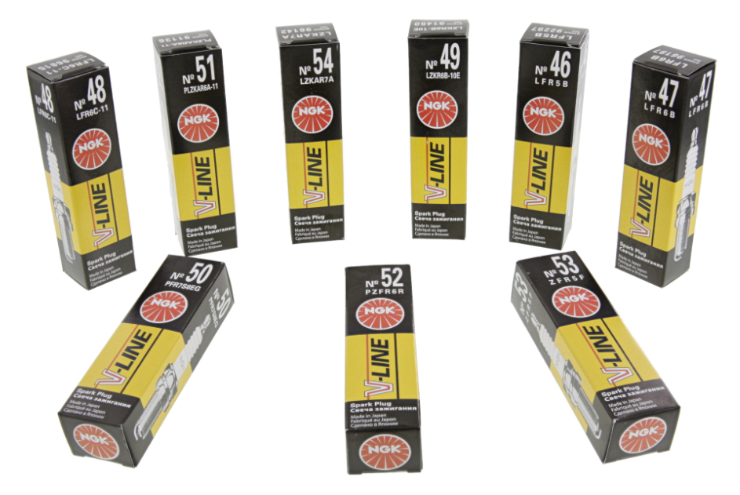

**Competitor Information**

As all items fit for an attractive amount of applications competitors have entered the market already. However: As all NGK spark plugs follow the OE business they do have an outstanding quality and ignition performance. A list with competitor cross references can be downloaded with the link provided at the end of this document.

**USP’s**

* References with high car park coverage
* All items follow NGK OE business with outstanding quality and ignition performance
* High name recognition of V-Line range
* Simple stocking and inventory management due to short-number system
* References PFR7S8EG, PLZKAR6A-11 and PZFR6R have a platinum tip on the center electrode offering high resistance against wear

**European Car ParK by type AND by country\***

The new references significantly increase the car park coverage of the V-Line product range by more than 16 million vehicles in year 2017 which is more than 8% coverage increase on European car park base.

**Development of European car park by spark plug type**



* Source: Headline car park 2015 and forecast 2016 - 2020



**Car park by type and country – year 2017**



* Source: Headline car park 2015 and forecast 2016 - 2020

**Pricing**

For product prices please contact your NGK sales team.

**Availability**

All spark plugs are available from today.

**Marketing Tools**

The following tools are available for you by the attached links:

* Product Pictures

[Link](http://dave.ngk.de/index.php?dld=_ZTgzNjJlOGYvYXNzZXRzL2RhdmVfMDM3NGFlZTEuemlwIzEyNQ==)

* Application Data & Cross-List

[Link](http://dave.ngk.de/index.php?dld=_NWZiNjk3NTQvYXNzZXRzL2RhdmVfZWU4ZGNhMTMuemlwIzEyNQ==)

Do not hesitate to complete your product portfolio with the new NGK V-Line references!

Best regards

Your NGK Team